Hi there, welcome to your password cracking mission. This is gonna be fun. Get through all the layers of passwords, submit the final one for the flag, and you’ll get your points, and hopefully learn to use hash cracking tools (responsibly!!!)
Start off with the most basic attack, also known as the…
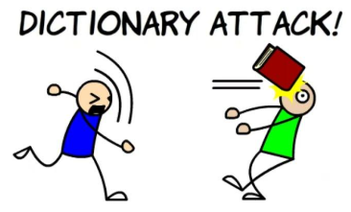
You just have to spray a list of words at the hash until one matches! It’s so simple! And you guessed it, it works on bad passwords. This method will rock your world. To help you get started, I’ll even give you the hash for this layer (I won’t be so nice next time)
Hash: ab5eab424918cb882e98c068e79490c36347d743
I hear there is a cat that will crack hashes for you if you ask him. Find the cracker tool, get yourself a basic wordlist, crack the hash, and use the password to unzip the zip file… Good luck!

